Brain Tumor and Alzheimer's Detection using MRI Scans
A Project Report submitted in partial fulfillment of the requirements for the award of the degree of

Bachelor of Technology

in
Computer Science and Engineering/
Electronics and Communication Engineering

by

Akshat Dhongade (112315014)

Dawinder Kumar (112315049)

Aashay Degvekar (112315051)

Ashish Yadav (112316008)

Under the Supervision of: Dr. Priyank Jain

Semester: 5


Department of Computer Science and Engineering/ Department of Electronics and Communication Engineering

Indian Institute of Information Technology, Pune

(An Institute of National Importance by an Act of Parliament)

December 2025

BONAFIDE CERTIFICATE

This is to certify that the project report entitled “Brain Tumor and Alzheimer’s Detection using MRI Scans” submitted by Akshat Dhongade bearing the MIS No: 112315014, Dawinder Kumar bearing the MIS No: 112315049, Aashay Degvekar bearing the MIS No: 112315051 and Ashish Yadav bearing the MIS No: 112316008, in completion of his project work under the guidance of Dr. Priyank Jain is accepted for the project report submission in partial fulfillment of the requirements for the award of the degree of Bachelor of Technology in the Department of Computer Science and Electronics and Communication Engineering, Indian Institute of Information Technology, Pune (IIIT Pune), during the academic year 2025-26.

Dr. Priyank Jain Dr. Bhupendra Singh
Project Supervisor Head of the Department
Designation of the Supervisor Assistant Professor
Department of the Supervisor Department of CSE
IIIT Pune IIIT Pune

Project Viva-voce held on 1-12-2025

Undertaking for Plagiarism
We Akshat Dhongade, Dawinder Singh, Ashay Degvekar and Ashish Yadav solemnly declare that research work presented in the report/dissertation titled “Brain Tumor and Alzheimer’s Detection using MRI scans” is solely our research work with no significant contribution from any other person. Small contribution/help wherever taken has been duly acknowledged and that complete report has been written by us. We understand the zero tolerance policy of Indian Institute of Information Technology, Pune towards plagiarism. Therefore we declare that no portion of my report has been plagiarized and any material used as reference is properly referred/cited. I undertake that if I am found guilty of any formal plagiarism in the above titled thesis even after award of the degree, the Institute reserves the rights to withdraw/revoke my B.Tech degree.

Student’s Name and Signature with Date

Akshat Dhongade

Dawinder Kumar

Aashay Degvekar

Ashish Yadav

Conflict of Interest
Manuscript title: Brain Tumor and Alzheimer's Detection using MRI Scans.
The authors whose names are listed immediately below certify that they have NO affiliations with or involvement in any organization or entity with any financial interest (such as honoraria; educational grants; participation in speakers’ bureaus; membership, employment, consultancies, stock ownership, or other equity interest; and expert testimony or patent-licensing arrangements), or non-financial interest (such as personal or professional relationships, affiliations, knowledge or beliefs) in the subject matter or materials discussed in this manuscript.

Akshat Dhongade

Dawinder Kumar

Aashay Degvekar

Ashish Yadav

ACKNOWLEDGEMENT

This project would not have been possible without the help and cooperation of many. I would like to thank the people who helped me directly and indirectly in the completion of this project work.

First and foremost, I would like to express my gratitude to our honorable Director, Prof. Shireesh B. Kedare, for providing his kind support in various aspects. I would like to express my gratitude to my project guide Dr. Priyank Jain, Department of CSE, for providing excellent guidance, encouragement, inspiration, constant and timely support throughout this B.Tech Project. I would like to express my gratitude to the Head of Department (
Dr. Bhupendra Singh), Department of CSE, for providing his kind support in various aspects. I would also like to thank all the faculty members in the Department of CSE and my classmates for their steadfast and strong support and engagement with this project.

Title

Abstract

Brain diseases such as tumors and Alzheimer’s disease affect millions of people globally. These conditions are often detected too late, which limits the effectiveness of treatment. Early diagnosis is critical to improving patient recovery rates and overall quality of life. In this project, we have worked on a Deep Learning (DL) based approach to automate the detection of these disorders using Magnetic Resonance Imaging (MRI) scans.

We developed a system using Convolutional Neural Networks (CNN) to classify MRI scans into three distinct categories: Normal, Tumor, and Alzheimer’s. The process involves preprocessing the MRI images using OpenCV for noise removal, grayscale conversion, and segmentation. These processed images are then fed into a CNN architecture built using TensorFlow. We also utilized data augmentation techniques to increase the diversity of our training data and prevent overfitting.

The performance of our CNN model was compared against other algorithms such as Random Forest (RF), Support Vector Machine (SVM), and Genetic Algorithms (GA). The experimental results demonstrate that the CNN model achieves the highest accuracy of approximately 91.2% and an efficiency of 92.02%, outperforming the traditional machine learning methods. This study confirms that deep learning models can provide reliable, consistent, and fast diagnostic assistance to doctors, potentially reducing the burden on the healthcare system.

Keywords: Brain Tumor, Alzheimer’s Disease, Deep Learning, CNN, MRI, Medical Imaging.

TABLE OF CONTENTS

Abstract i
List of Figures/Symbols/Nomenclature iv
List of Tables v
- Introduction 1
1.1 Overview of work . . . . . . . . . . . . . . . . . . . . . . . . . . . . . . . . . . 1
1.2 Literature Review . . . . . . . . . . . . . . . . . . . . . . . . . . . . . . . . . 2
1.3 Motivation of work. . . . . . . . . . . . . . . . . . . . . . . . . . . . . . . . . . 4
1.4 Research Gap. . . . . . . . . . . . . . . . . . . . . . . . . . . . . . . . . . . . . 6
- Problem Statement 7
2.1 Research Objectives . . . . . . . . . . . . . . . . . . . . . . . . . . . . . . . . . 8
2.2 Analysis And Design . . . . . . . . . . . . . . . . . . . . . . . . . . . . . . . . . 10
- Proposed Work 11
3.1 Methodology of Work. . . . . . . . . . . . . . . . . . . . . . . . . . . . . . . . 12
3.2 Hardware & Software Specifications. . . . . . . . . . . . . . . . . . . . . . . . . 14
3.3 Dataset Description. . . . . . . . . . . . . . . . . . . . . . . . . . . . . . . . . 15
- Results and Discussion 19
- Conclusion and Future Scope 22
References
Publication (if any)

List of Figures / Symbols/ Nomenclature

List of Tables
Chapter 1
Introduction

Overview of Work (First Sub-Heading, 14 Times New Roman)

Brain disorders, specifically brain tumors and Alzheimer’s disease, are critical health issues that require timely intervention. A brain tumor involves the abnormal growth of cells within the brain, while Alzheimer’s is a progressive disorder that causes brain cells to waste away (degenerate) and die. The traditional method for diagnosing these conditions involves a radiologist or a specialist manually examining MRI scans. This process relies heavily on human expertise, which can sometimes lead to variability in diagnosis due to fatigue or experience levels.
This project focuses on detection process using Deep Learning. We utilize Deep Learning, specifically Convolutional Neural Networks (CNNs), which are highly effective at image recognition tasks. By feeding the model MRI scans, the system learns to identify patterns associated with tumors or Alzheimer's that might be subtle to the human eye. The goal is to create a support tool that helps doctors make faster and more accurate decisions.

Literature Review

To understand the current state of research, we reviewed several recent papers in the field of medical imaging and deep learning.
- "A Novel Neuroimaging Based Early Detection Framework for Alzheimer’s Disease Using Deep Learning (NEDA-DL)" (2025): Taseer Muhammad et al. proposed a framework that achieved 92.87% accuracy. They used both structural and functional imaging. However, the study noted that real-world generalizability was limited due to the diversity of the dataset used.
- "Brain tumor detection from images and comparison with transfer learning methods" (2024): Muhammet Sinan Başarslan et al. compared standard CNNs with transfer learning models like VGG16. They achieved up to 94% accuracy. A key gap identified was that the dataset was not sufficiently augmented (rotated or cropped), which could reduce robustness.
- "Brain disease research based on functional magnetic resonance imaging data and machine learning" (2023): Na Li et al. conducted a comprehensive review of 55 studies. They highlighted the importance of feature fusion and multimodal data. The gap identified was that many datasets were small and heterogeneous, leading to poor generalization.
- "Brain Tumor Detection Using Machine Learning and Deep Learning Approaches" (2022): Rajeswari Devarajan et al. integrated ML and DL methods. Their work highlighted the lack of large, standardized, annotated MRI datasets and limited discussion on model explainability.

1.3 Motivation of the Work
The motivation behind this project is driven by several key factors:
- Early Detection Saves Lives: Detecting brain tumors or Alzheimer’s in the initial stages allows for faster treatment, which significantly improves survival chances and management of the disease.
- Reliable and Consistent Diagnosis: Human diagnosis can vary. A Deep Learning based system ensures consistent accuracy and is not subject to fatigue or subjective bias.
- Personalized Treatment Insights: Advanced models can identify specific disease patterns, helping doctors design treatment plans tailored to the specific patient.
- Reduced Healthcare Burden: Automation speeds up the analysis of scans. This helps hospitals manage more patients efficiently without compromising on the quality of diagnosis.

  - Research Gap
Based on the literature review, we identified specific gaps that our project aims to address or improve upon:
- Existing studies often lack robust data augmentation, leading to models that fail when images are rotated or zoomed.
- Many previous models lack interpretability (explainability), making it hard for doctors to trust the "black box" decisions.
- There is a need for a unified system that can handle multiple conditions (Tumor and Alzheimer's) rather than just one.

Chapter 2

Problem Statement

The current standard for diagnosing brain diseases involves manual analysis of MRI scans. This process is time-consuming, expensive, and prone to human error. As the number of patients increases, radiologists face a heavy workload, which can delay diagnosis. Furthermore, early signs of Alzheimer's or small tumors can be easily missed in complex MRI imagery. The problem is to develop a computational system that can automatically, accurately, and quickly classify brain MRI scans to assist medical professionals.

2.1 Research Objectives

The primary objectives of this project are:
- To develop a Deep Learning model (CNN) capable of analyzing MRI scans.
- To accurately classify scans into three categories: Normal Brain, Brain with Tumor, and Alzheimer’s Brain.
- To implement image preprocessing techniques (noise removal, segmentation) to improve model accuracy.
- To compare the performance of the proposed CNN model with traditional Machine Learning algorithms.
- To generate saliency maps that highlight the regions of the brain the model is focusing on, improving interpretability.

2.2 Analysis and Design

The system design follows a pipeline approach. It begins with the Input Layer, where raw MRI images are fed into the system. These images go through Preprocessing, which includes converting them to grayscale, removing noise to clear up the image, and segmenting the region of interest (the brain)

The core of the design is the CNN Architecture. This consists of multiple "Convolutional Blocks." Each block contains:
- Conv2D Layers: To extract features like edges and textures.
- Batch Normalization: To stabilize the learning process.
- MaxPooling2D: To reduce the size of the image while keeping important features.
- Activation Functions (ReLU): To introduce non-linearity.

Finally, the data passes through Fully Connected Layers and a Softmax Output Layer which gives the probability of the image being Normal, Tumor, or Alzheimer’s.

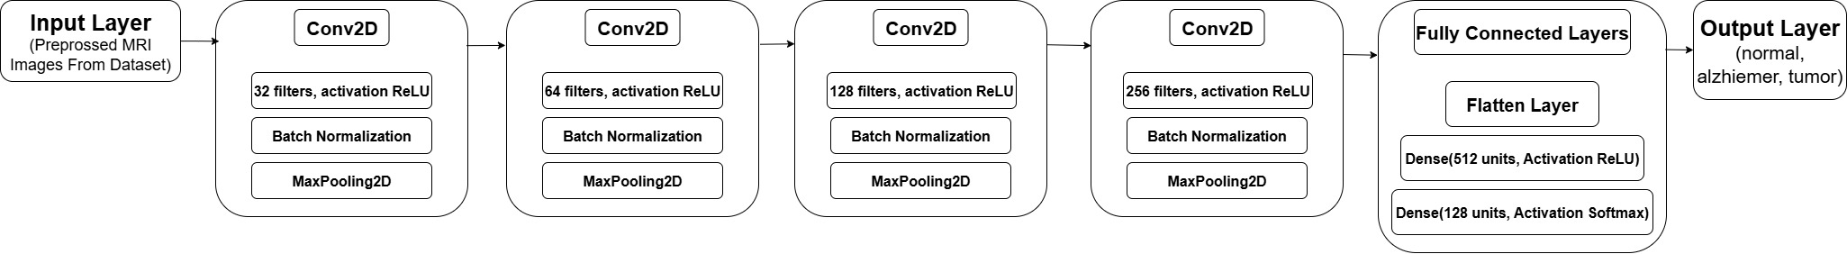 Convolutional Convolutional Convolutional Convolutional
Block 1 Block 2 Block 3 Block 4

Chapter 3

Proposed Work

3.1 Methodology of work

Our methodology consists of several distinct stages:
- Data Collection: We collected MRI scans from open-source repositories like Kaggle and Open-Neuro. The dataset includes three classes of images: Tumor, Alzheimer’s, and Healthy.
- Preprocessing: Before training, raw images are cleaned.
  - Grayscale Conversion: Converting RGB images to single-channel grayscale to simplify processing.
  - Noise Removal: Removing grainy artifacts common in medical scans.
  - Image Segmentation: Isolating the brain area from the skull and background.
  - Resizing: Ensuring all images are the same dimension for the neural network.
- Data Splitting: The dataset is divided into Training (75%), Validation (12.5%), and Testing (12.5%) sets.
- Data Augmentation: To prevent the model from memorizing the training data (overfitting), we artificially created new training examples by rotating, flipping, and zooming existing images.
- Model Building & Training: We constructed a CNN using TensorFlow. The model is trained using backpropagation and gradient descent. We fine-tuned hyperparameters like filter sizes and learning rates to get the best performance.

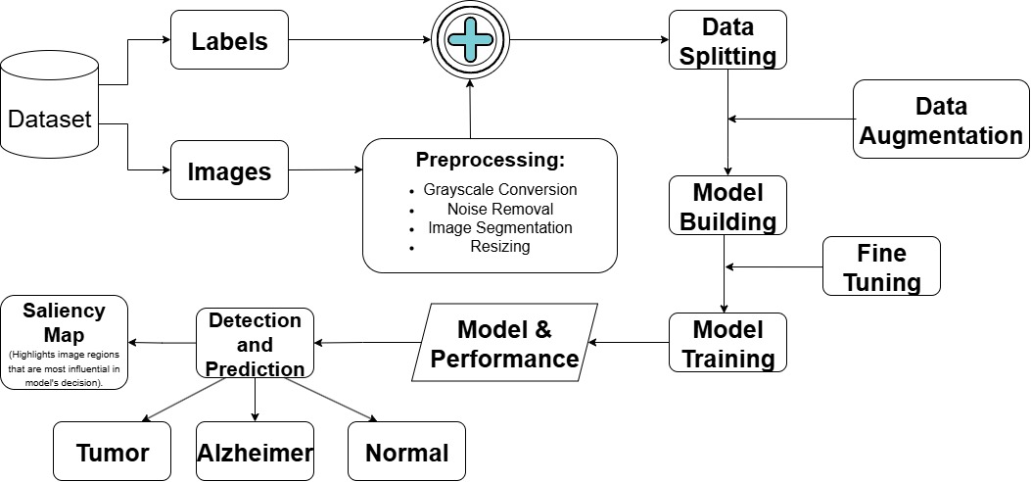

3.2 Hardware & Software specifications

Software:
- Python: The primary programming language used for the project.
- TensorFlow: An open-source library used to build and train the Deep Learning model.
- OpenCV: Used for image processing tasks like segmentation and noise removal.
- NumPy & Pandas: Used for numerical operations and data handling.
- Matplotlib: Used for plotting graphs of accuracy and loss.

Hardware:
- The model was trained on a system capable of handling matrix operations, utilizing a GPU for faster processing where available.

3.3 Dataset Description

The dataset is the foundation of our model. We utilized publicly available medical imaging datasets.
- Source: Kaggle, Open-Neuro.
- Input Data: MRI (Magnetic Resonance Imaging) scans.
- Classes:
  - Normal: Scans showing healthy brain structure.
  - Tumor: Scans showing abnormal mass growth.
  - Alzheimer’s: Scans showing brain atrophy (shrinkage) typical of the disease.

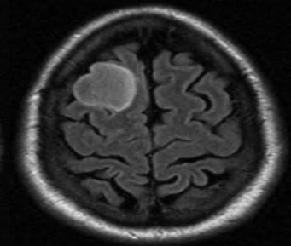
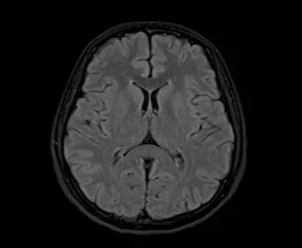
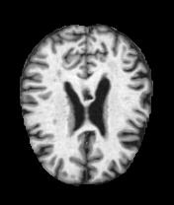
Tumor
Normal
Alzheimer
Input:
Output:

Chapter 4

Results and Discussion

We evaluated our model using standard performance metrics: Accuracy (overall correctness), Precision (reliability of positive predictions), and Recall (ability to detect actual cases).

We compared our custom CNN model against other common algorithms including Random Forest (RF), Support Vector Machine (SVM), and Genetic Algorithms (GA).

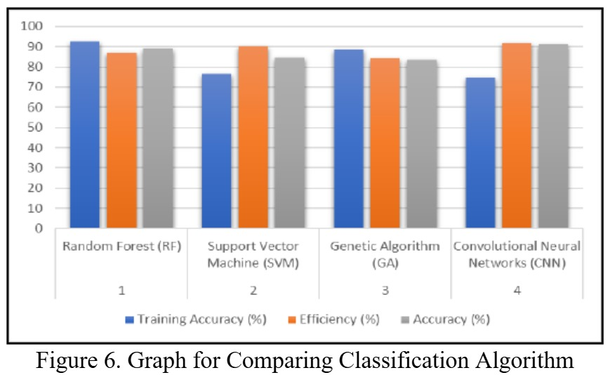

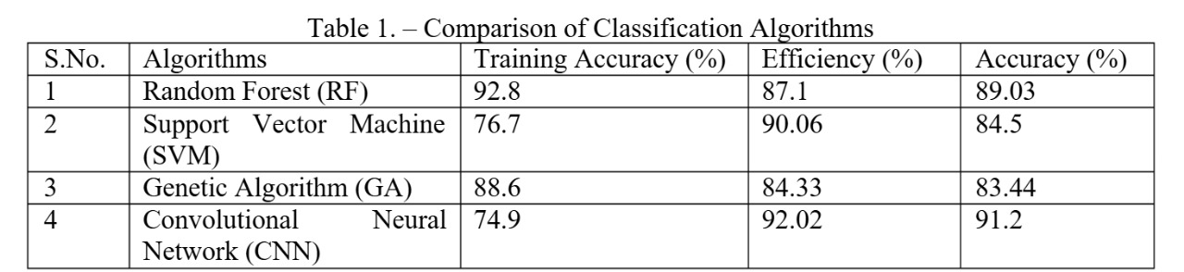

Discussion: As shown in the table, the CNN model achieved the highest testing accuracy of 91.2% and the highest efficiency of 92.02%. While Random Forest had high training accuracy, it did not perform as well on the final accuracy metric, suggesting CNN generalizes better to new data. SVM and Genetic Algorithms performed reasonably well but were outperformed by the Deep Learning approach.

We also analyzed the training curves. The training and validation accuracy increased steadily over epochs, while the loss decreased, indicating that the model was learning effectively without significant overfitting.

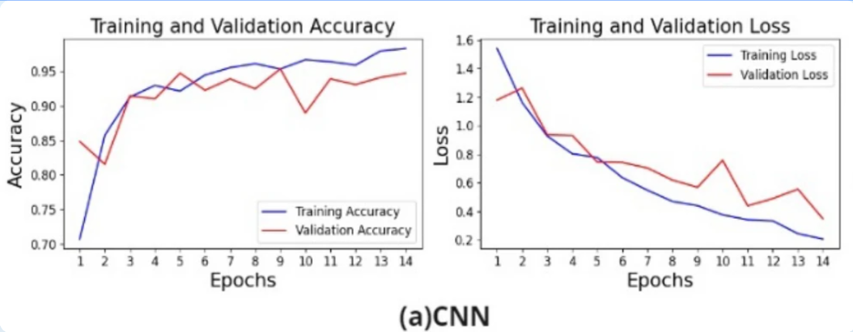

Chapter 5

Conclusion and Future Scope

Conclusion: This project successfully developed an advanced deep learning model for the automated detection of Brain Tumors and Alzheimer’s Disease using MRI scans. The custom CNN architecture, implemented with TensorFlow and OpenCV, achieved an accuracy of 91.2%, which is higher than the traditional machine learning approaches discussed in our results. This demonstrates the strong potential of automated diagnostic systems in providing faster, more reliable, and consistent medical image analysis, contributing significantly toward early detection and better patient outcomes.

Future Scope: While the current system is effective, there are several areas for future improvement:
- Model Explainability (XAI): We aim to integrate techniques like Grad-CAM to visualize exactly which parts of the MRI the model is looking at. This will build trust with doctors.
- 3D Volume Analysis: Currently, the model looks at 2D slices. Future work involves using 3D Convolutional Networks to analyze the entire volume of the brain for better accuracy.
- Cloud and Edge Deployment: Optimizing the model to run on cloud platforms or portable edge devices would make it accessible in remote areas.
- Integration with EMR Systems: Developing a user interface that connects directly with hospital Electronic Medical Records (EMR) for seamless workflow integration.

References

Syed Saad Azhar Ali, Khuhed Memon, Norashikin Yahya & Shujaat Khan. (2025). Deep learning frameworks for MRI-based diagnosis of neurological disorders: a systematic review and meta-analysis.

Areej Alasiry et al. (2025). A novel neuroimaging based early detection framework for Alzheimer disease using deep learning.

Mohammad Zafer Khaliki & Muhammet Sinan Başarslan. (2024). Brain tumor detection from images and comparison with transfer learning methods and 3-layer CNN.

Jyotismita Chaki & Gopikrishna Deshpande. (2024). Brain Disorder Detection and Diagnosis using Machine Learning and Deep Learning – A Bibliometric Analysis.

Divya Saxena, Sukaant Chaudhary. (2023). Predicting Brain Diseases from FMRI-Functional Magnetic Resonance Imaging with Machine Learning Techniques for Early Diagnosis and Treatment.

Jing Teng, Chunlin Mei, Jian Shi, Na Li. (2023). Brain disease research based on functional magnetic resonance imaging data and machine learning: a review.

Oneza Tehreem Khan & Rajeswari D. (2022). Brain Tumor detection Using Machine Learning and Deep Learning Approaches.

Instructions

- All the pages should be numbered at the bottom right side of the page.
- All the References should be mentioned in the APA format.
- All the tables and figures should be captioned properly. The compiled list of the tables and figures should be presented in the appendix.
- The report should be original in its work. Maximum 20% of plagiarism is permissible. Students must attach an Undertaking for plagiarism report at the designated place of the report.
- The students must get the report verified, evaluated and signed by the supervisor before its final submission in the spiral bound form and incorporate any changes, suggestions or recommendations as directed by the supervisor.
- The students should bring the final report (spiral bound) on the day of End-Semester Project Presentation and submit it to their respective panelists.
- The format of BTP/MTP report shared should be strictly followed.
- The Problem Statement and Objectives submitted during the Mid-Term Presentation must be attached to the Final report after the Bonafide certificate given in the sample report.
- The order of report should be in the following format:
- Title Page
- Bonafide Certificate, Conflict of Interest and Undertaking for Plagiarism
- Problem statement and objectives submitted during the Mid-Term Presentation (Internship students should skip this section)
- Abstract with keywords
- Contents
- Chapters as suggested in report

11. All the data/tables/figures taken from other sources should be duly credited in the footnotes or references.
12. The font size should be 12 throughout the document. The title should be Font size 17 and sub-heading should be Font Size 14, followed by under subheadings as Font Size 12. The Font Style must be Times New Roman Only and spacing between each line must be 1 and between headings should be 2.
13. The spacing between each line must be 1.15 and between headings must be 2.
14. All the paragraphs must be aligned as “justify” while the headings must be in center, the sub-headings should be left aligned.
15. Do attach the “Progress Report” duly signed by your respective supervisor at the end of the report.
16. Internship students’ needs to attach completion certificate from the company at the end of the report.

